**Quarterly Report – Public Page**

**Date of Report:** 8th Quarterly Report - October 7, 2024

**Contract Number:** *693JK32210015POTA*

**Prepared for:** *DOT-PHMSA*

**Project Title:** *Dynamic Geohazard Risk and Decision Support Platform*

**Prepared by:**  *Boston Geospatial, Inc.*

**Contact Information:**  *Justin Oliveira,* [*justin@bostongeospatial.com*](mailto:justin@bostongeospatial.com)*, 321-720-3568*

**For quarterly period ending:** *September 30, 2024*

**1: Items Completed During this Quarterly Period:**

A detailed overview of the progress this past quarter is provided in the various sections below.

| ***Item #*** | ***Task #*** | ***Activity/Deliverable*** | ***Title*** |
| --- | --- | --- | --- |
| 23 | 6.3 | GIS Interface | Submit GIS Implementation Guideline Documentation |
| 38 | 0.1 | 8th Quarterly Status Report | Submit 8th quarterly report |

**2: Items Not-Completed During this Quarterly Period:**

| ***Item #*** | ***Task #*** | ***Activity/Deliverable*** | ***Title*** |
| --- | --- | --- | --- |
| 24 | 7.1 | Integration | API service integration and client management setup; ArcGIS tool ribbon development |
| 25 | 7.2 | Integration | Submit consolidated API documentation and ArcGIS ribbon user's manual |
| 26 | 8.1 | Backtesting | Backtesting of tool with TAP operators |
| 28 | 8.1 | Backtesting | Backtesting of tool with TAP operators |

**3: Project Financial Tracking During this Quarterly Period:**

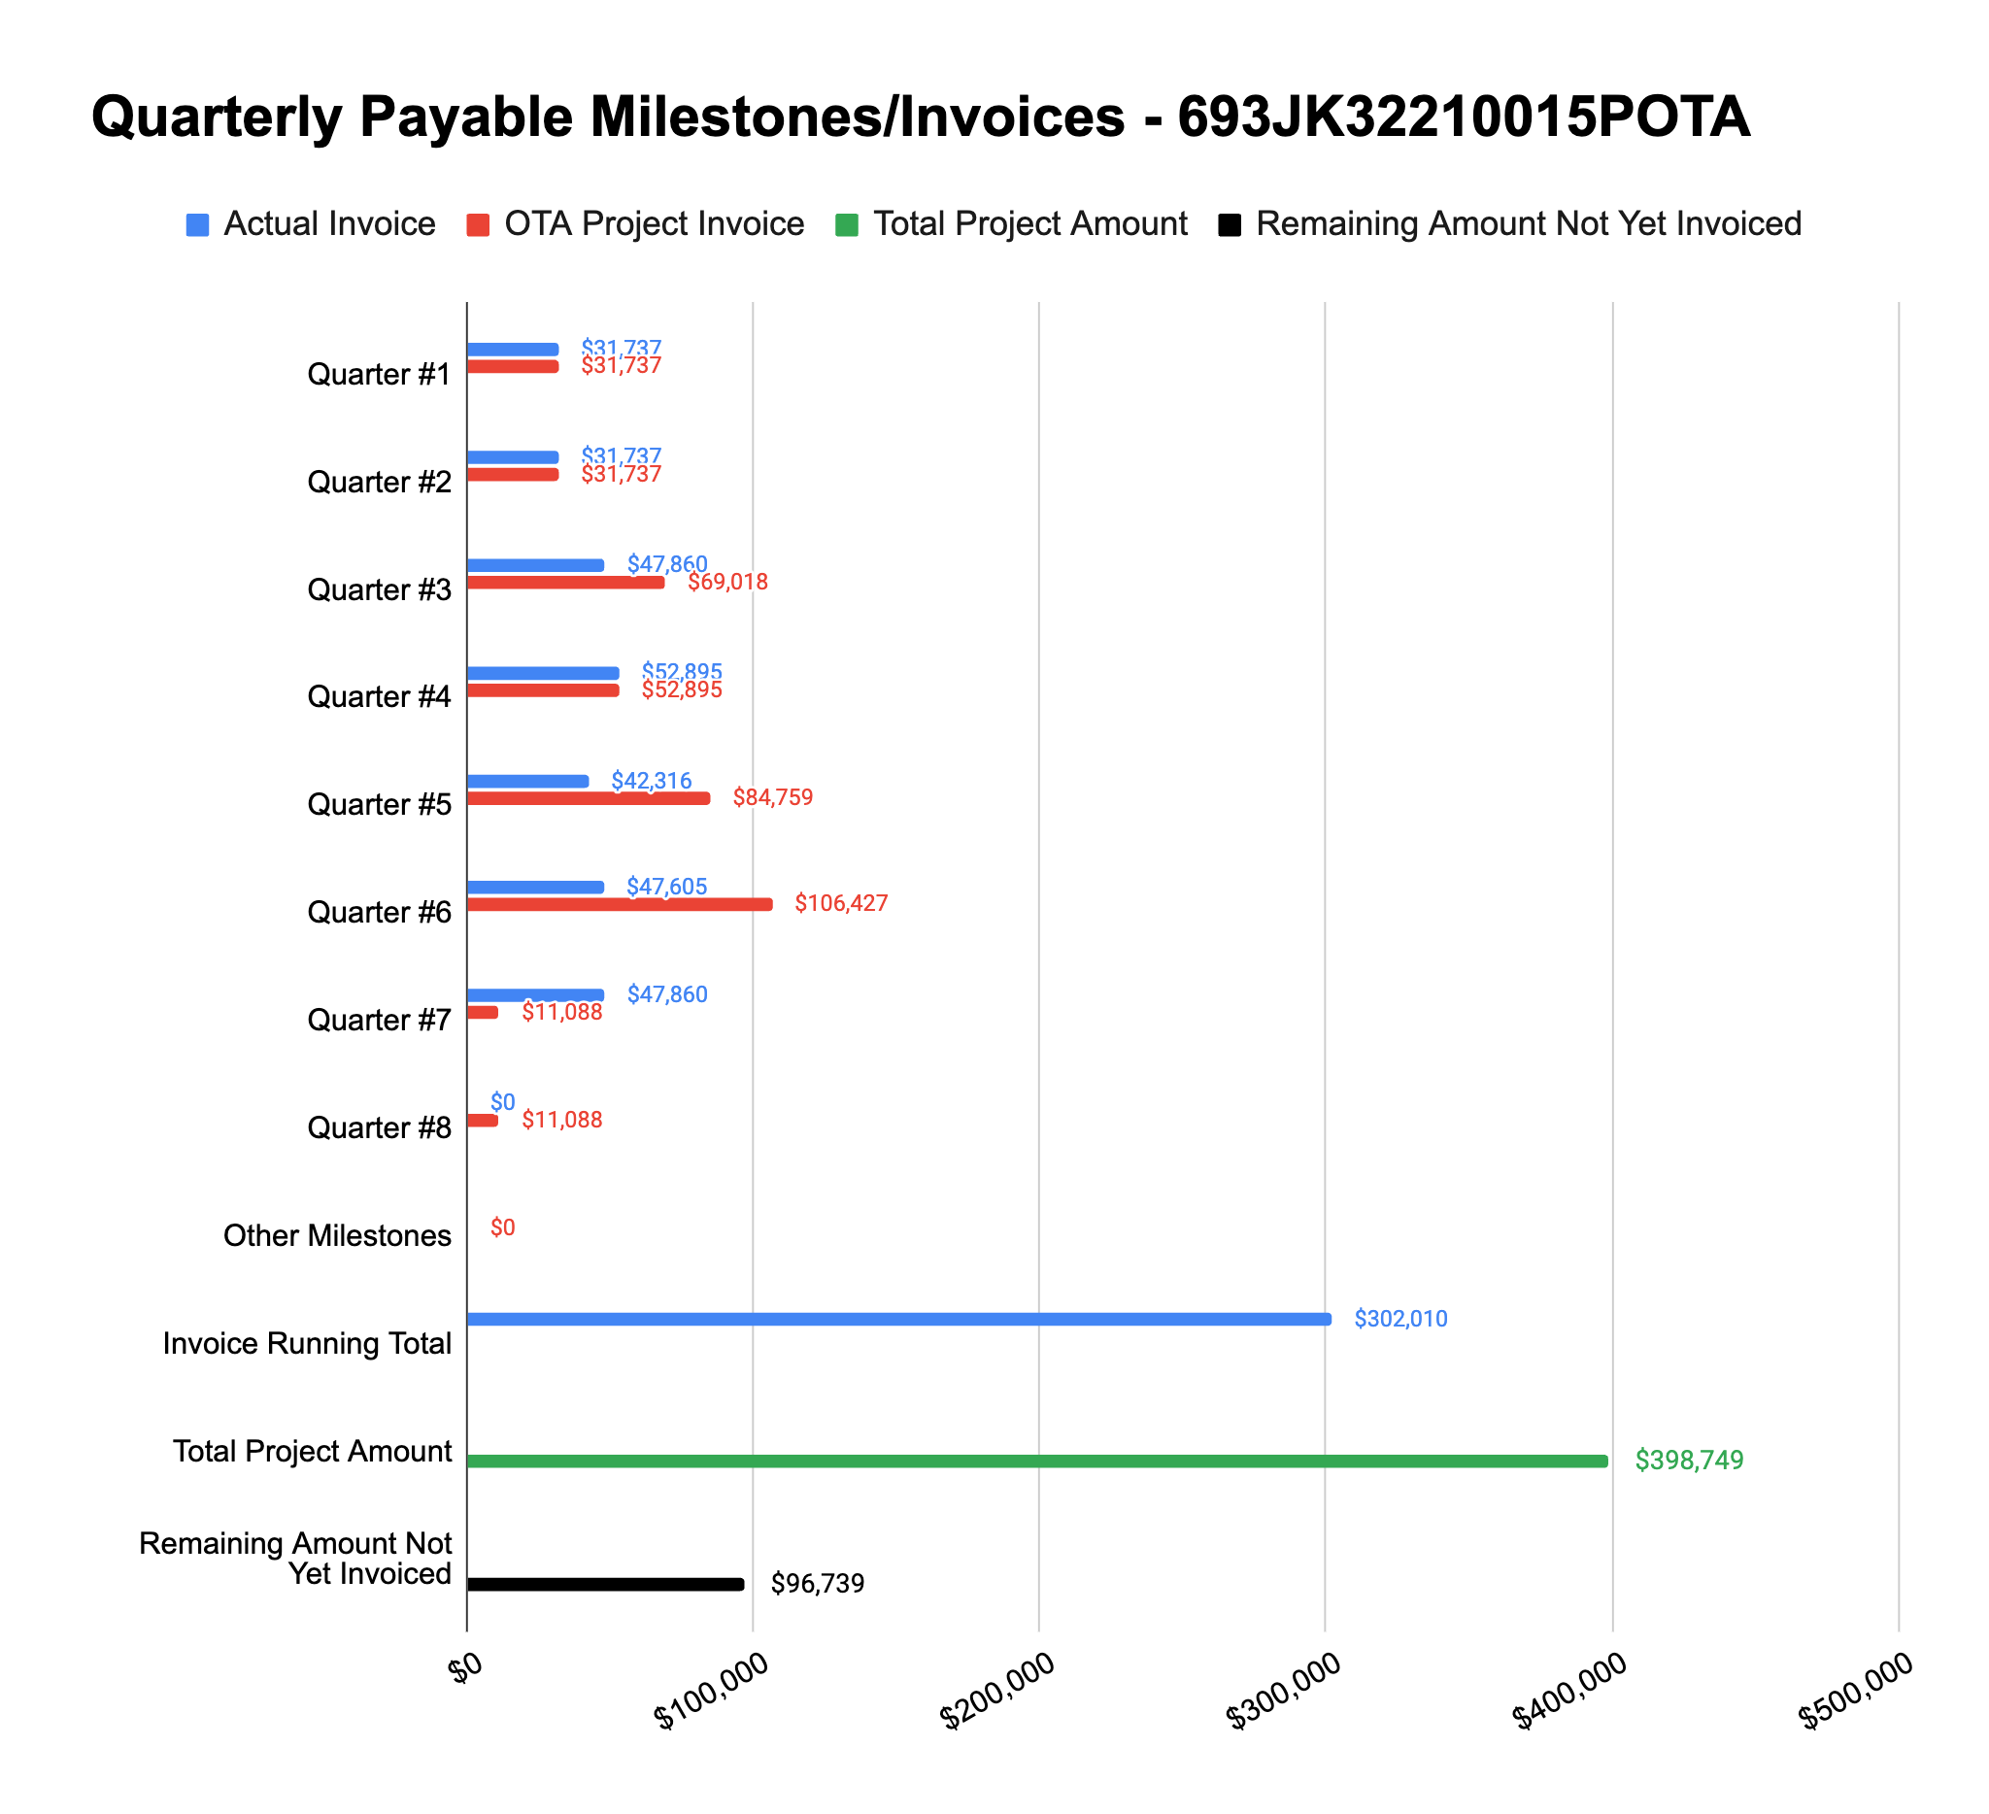

**4: Project Technical Status –**

**Item# 23 / Task# 6.3/ GIS Interface / Submit GIS Implementation Guideline Documentation**

Since our last update, we have completed this task. A copy of the documentation can be found in the project cabinet on PRIMIS.

**Item# 24 / Task# 7.1/ Integration / API service integration and client management setup; ArcGIS tool ribbon development**

Since our Q7 status report, we have made a lot of progress on this specific item. Over the past quarter in working to complete this task, we ran into a licensing issue with Esri that was preventing us from utilizing some of the needed functionality in ArcGIS Pro. We resolved that about six weeks back and have been working to complete this task since. Over the past month and half, we shifted a lot of resources to recruiting operators for our TAP and we also had a key team member out sick for a week - this has delayed the completion of this task. With the key member now back and about caught up, we will be working to close out this task in the next couple of weeks.

**Item# 25 / Task# 7.2/ Integration / Submit consolidated API documentation and ArcGIS ribbon user's manual**

Work on this item will be delayed until the completion of Item 24 is completed. Once Item 24 is complete, this item (Item 25) should be completed within 1-2 weeks thereafter. The reason for this is that there are a series of flowcharts that need to reflect the final ArcGIS implementation nuances, and they will be key components of the documentation.

**Item# 26 / Task# 8.1/ Integration / Backtesting of tool with TAP operators**

With our no-cost extension approved, we now have extra time in the schedule to continue our engagement efforts with operators and try to recruit two or more of them to join the TAP. Progress on this task will be deferred until we can onboard the first operator to the TAP and conduct engagements.

**Item# 28 / Task# 8.1/ Integration / Backtesting of tool with TAP operators**

Please refer to our comments in the Item 26 section above.

**Item# 38 / Task# 0.1/ 8th Quarterly Status Report / Submit 8th quarterly report**

Additional detail not necessary - this report constitutes the deliverable for Item# 38 / Task# 0.1.

**5: Project Schedule –**

With the re-baselined schedule now approved, our project is on schedule. We will be completing Task 7.1 and 7.2 within the refactored timelines. The primary schedule risk at the moment lies in the uncertainty around TAP backtesting - since we are still working to recruit operators to the TAP.

Since our last quarterly update, we have focused considerable resources on and been busy conducting an outreach campaign to recruit operators to the TAP. Those efforts have targeted geohazard POCs at 27 separate operators. So far, 2 operators have formally declined to participate, 15 have not responded (despite several attempts and approaches to engagement), and 10 we are in active discussion with. We hope that, from the group we are in discussions with, we can get at least two willing and able to join the TAP in the next month or so before the Holiday season.